Waypoint Module

Architecture/Design Document

**Table of Contents**

1 Introduction 3

2 Design Goals 4

3 System Behavior 4

4 Logical View 5

4.1 High-Level Design (Architecture) 5

4.2 Mid-Level Design 6

4.3 Detailed Class Design 8

5 Process View 11

6 Development View 12

7 Physical View 12

8 Use Case View 12

Change History

**Version:** <1.0>

**Modifier:** Nick

**Date:** 2/25/2020

**Description of Change:** File started and created

**Version:** <1.1>

**Modifier:** Nick

**Date:** 3/4/2020

**Description of Change:** Another diagram added. More details added

______________________________________________________

# Introduction

This document is for the waypoint system that was developed for Samurai Intellectuals game Just Survive. The waypoints are to help the AI navigate the map.

# Design Goals

The goal of this system is to keep the logic of the waypoints to the waypoints and keep the AI only knowing about the waypoint that it needs to go to next. It will also allow the designers to design the paths that the enemies follow with minimal issues and a lot of ways to expand.

# System Behavior

The waypoint group will hold waypoints and get waypoints. The Waypoint manager will know about all the groups in order in which they are to be followed. The AI will know about the Waypoint manager and it will ask it for a new waypoint once it reaches its destination.

# Logical View

The waypoint system is its own system to handle waypoints. The AI asks the Waypoint manager for a waypoint and the waypoint manager asks gets a random waypoint from the proper group that the AI wants to move to.

## High-Level Design (Architecture of the Entire system)

The high-level view or architecture consists of 3 major components:

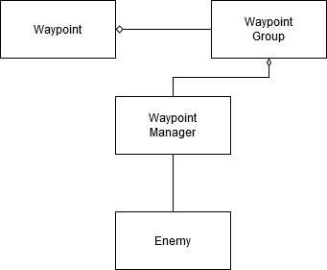

System Architecture

* The **Waypoint** is the point that the enemy actually moves to
* The **waypoint group** is a group to store the waypoints
* The **Waypoint manager** knows about the groups so that the Enemy only has to know about the manager

## Mid-Level Design of Module Waypoint system

<Explain and/or show static and dynamic aspects of subsystem components. Probably the most effective way of showing mid-level design is with class and sequence diagrams.>



## Detailed Class Design of Module Waypoints

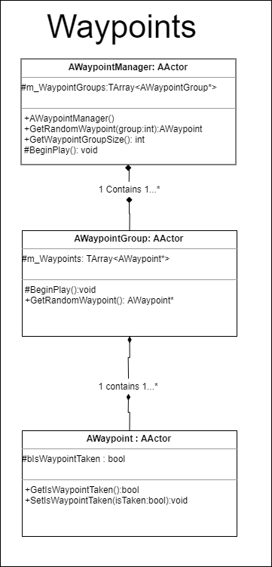

# Process View of Module Waypoints

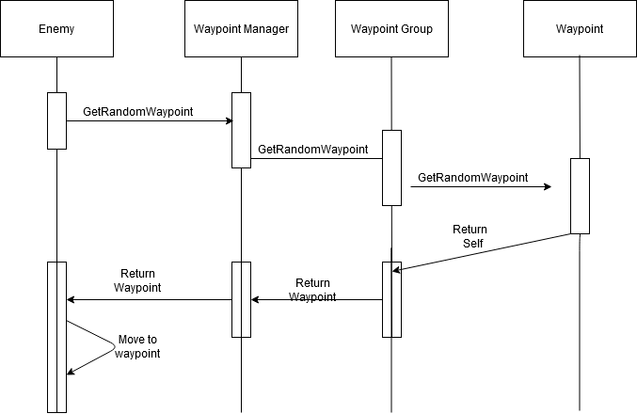

# Physical View (Applies to Multiplayer)

The waypoints and waypoint related logic should all be done on the server.

# Use Case View

The EnemyBase asks the waypoint manager for a waypoint and gives it the group it wants to go to. The waypoint manager uses the int and calls GetRandomWaypoint on the group of that index. The Waypoint group gets and returns a waypoint. The enemy ends up getting this waypoint from the waypoint manager.